EXPERIMENT: 5
DATE:16.07.26
Missionaries and Cannibals Problem

Aim:

To write a Python program to solve the Missionaries and Cannibals Problem using the Breadth-First Search (BFS) algorithm.

Algorithm:

- Read the number of missionaries and cannibals.
- Represent the initial state as (M_left, C_left, Boat) where the boat is on the left bank.
- Represent the goal state as (0, 0, Right).
- Use a queue to perform Breadth-First Search (BFS).
- Generate all valid boat moves:
  - 2 Missionaries
  - 2 Cannibals
  - 1 Missionary and 1 Cannibal
  - 1 Missionary
  - 1 Cannibal
- Discard any state where missionaries are outnumbered by cannibals on either bank.
- Continue until the goal state is reached.
- Display the sequence of states.

Program:

from collections import deque
def is_safe(m_left, c_left, total_m, total_c):
m_right = total_m - m_left
c_right = total_c - c_left
if m_left > 0 and m_left < c_left:
return False
if m_right > 0 and m_right < c_right:
return False
return True
def bfs(total_m, total_c):
start = (total_m, total_c, 'L')
goal = (0, 0, 'R')

queue = deque([(start, [start])])
visited = set()
while queue:
state, path = queue.popleft()
if state == goal:
return path
if state in visited:
continue
visited.add(state)
m_left, c_left, boat = state
moves = [
(2,0),
(0,2),
(1,1),
(1,0),
(0,1)
]
for m, c in moves:
if boat == 'L':
new_state = (m_left-m, c_left-c, 'R')
else:
new_state = (m_left+m, c_left+c, 'L')
nm, nc, nb = new_state
if 0 <= nm <= total_m and 0 <= nc <= total_c:
if is_safe(nm, nc, total_m, total_c):
if new_state not in visited:
queue.append((new_state, path+[new_state]))
return None
m = int(input("Enter number of Missionaries: "))
c = int(input("Enter number of Cannibals: "))
solution = bfs(m, c)
if solution:
print("\nSolution Found\n")
for state in solution:
print(state)
else:
print("No Solution Exists")

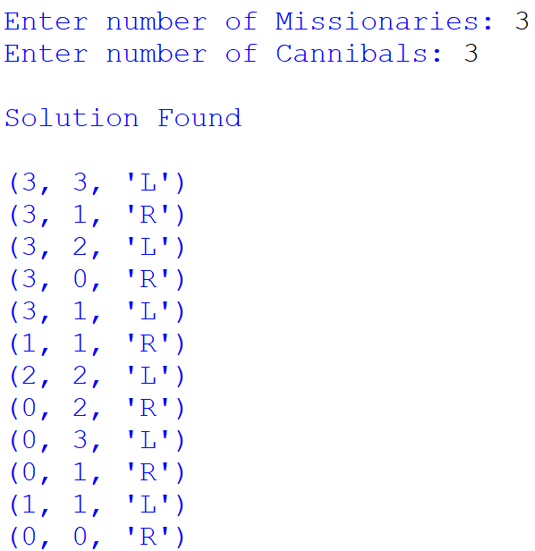
Output:

Result:

Thus, the Python program to solve the Missionaries and Cannibals Problem using the Breadth-First Search (BFS) algorithm was successfully executed, and all missionaries and cannibals crossed the river safely without violating the problem constraints.

